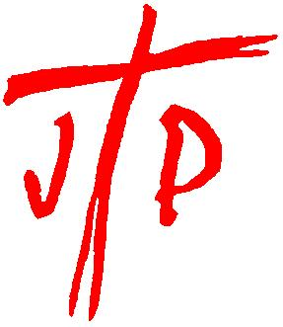 ADMINISTRATOR
National Justice & Peace Network
15 Hours per week, from 1 January 2019

Due to the retirement of our current post holder, NJPN seeks to recruit an Administrator to support the work of the Network: arranging meetings; networking with members and partnership organisations; developing effective communications between members and the wider public; co-ordinating the Annual Conference, guided and supported by the Executive Committee of NJPN.
A good knowledge of Catholic Social Teaching and an understanding of Church organisations is required.
Some travel within England & Wales will be necessary. Although the NJPN office is in London, some flexibility is possible with regard to the place of work.

Salary: £26,227 pro rata (including London allowance)
Closing date for applications: 5 pm Monday 15 October 2018

Further details:
Download the Application Pack from our website:
www.justice-and-peace.org.uk
Or contact Kevin Burr (Company Secretary)
Email: kevin@the-burrs.co.uk Tel: 07947 773 106

NJPN is a company limited by guarantee. A charity registered in England & Wales. Company registration no. 5036866 Registered charity no. 1114947
Registered Office 39 Eccleston Square, London SW1V 1BX

