**National Justice & Peace Network**

**40th Annual Conference**

**Organised in partnership with**

**Apostleship of the Sea,**

**Church Action on Poverty,**

**Housing Justice,**

**Prison Advice and Care Trust**

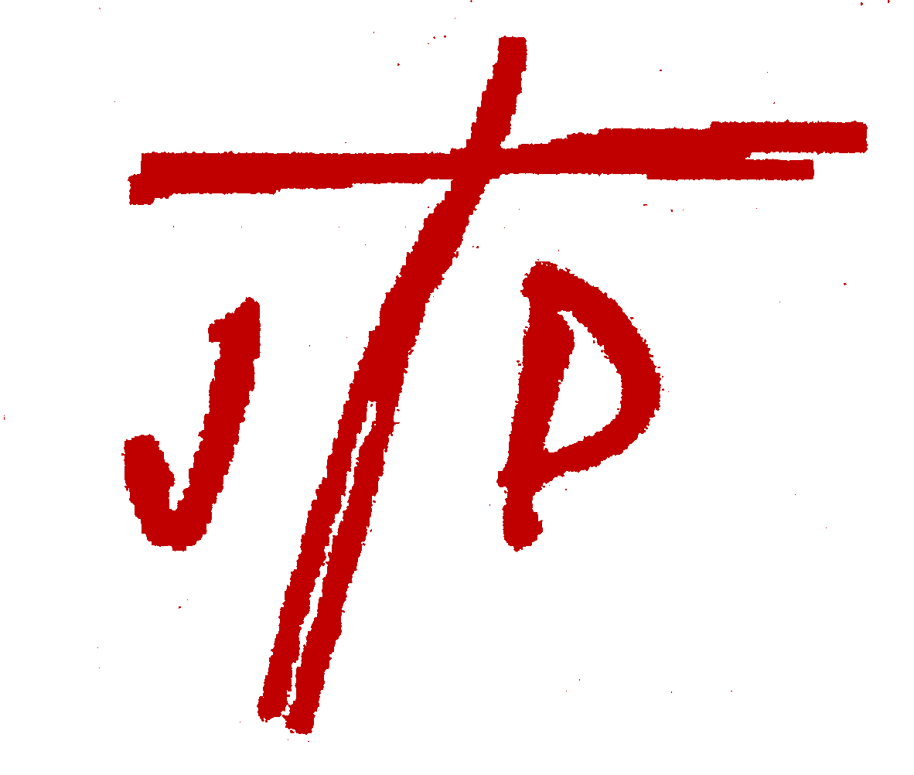

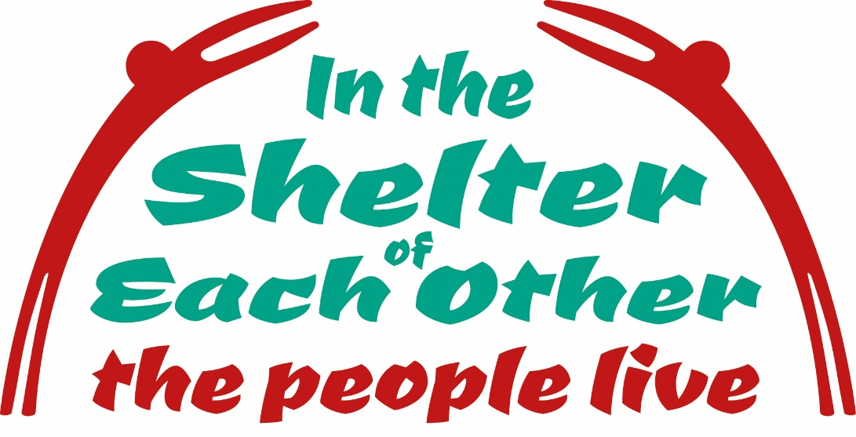

**Friday 20 - Sunday 22 July 2018**

The Hayes Conference Centre

Swanwick, Derbyshire

With programmes for children and young people

***‘In the Shelter of Each Other the People Live’***

How do we build a church and a society with the marginalised, the excluded and the most vulnerable at its heart? What does ‘home’ mean for those who are homeless or struggling to keep a roof over their heads, for those who have fled their homes, for those who are rejected or don’t ‘fit in’? And for the comfortable and secure, is it a space to defend or to open in welcome? Can we recognise that it is only in relationship with each other and with the earth that we share that we can all be truly ‘at home’?

**SPEAKERS**

**Rev Al Barrett** is Rector of Hodge Hill Church, a CofE-URC ecumenical partnership in east Birmingham. He lives on a diverse outer estate on the edge of the city, and has been involved in a journey of community-building there, with friends and neighbours, for the last 7 years. He writes and teaches a bit, blogs irregularly, at [www.thisestate.blogspot.com](http://www.thisestate.blogspot.com), and has recently finished a PhD, seeking to develop 'a radically receptive political theology in the urban margins'.

**David McLoughlin** teaches at Newman University. He is a theological resource person for Caritas Europe, Cafod, Pax Christi, the J&P network and various groups of Religious. He is a founder member of the Movement of Christian Workers and an active member of their Birmingham revue of life group for 30 years. He explores the relationship between theology and everyday life and offers radical readings of the Bible for Christian activists.

**Sarah Teather** has been Director of Jesuit Refugee Service UK since January 2016. She served for 12 years as MP in north west London. She stood down in 2015 and worked with JRS International, visiting refugee projects around the world, before taking up her present post.

**John Grogan MP** a Catholic, was elected in 2017 as Labour MP for Keighley and Ilkley, having previously been MP for Selby before boundary changes abolished the seat. He is committed to issues of social justice and peace, voting against Trident renewal.

**The Conference will be chaired by Housing Justice**

**CELEBRANT: Fr Colum Kelly**, Apostleship of the Sea port chaplain for Immingham.

**JUST FAIR**

Agencies will be displaying goods and resources, and information and ideas about practical action can be obtained at the “Just Fair” marketplace.

**CHILDREN AND YOUNG PEOPLE**

Children and young people are a vital part of the NJPN conference. There will be a crèche for children under 5 and a programme of activities for 5 to 11 year olds. 12 to 16/18 year olds will explore the conference theme in an active and thought provoking weekend.

NJPN is committed to the protection of children, young people and vulnerable people.

People of all ages and backgrounds are welcome & encouraged to attend conference.

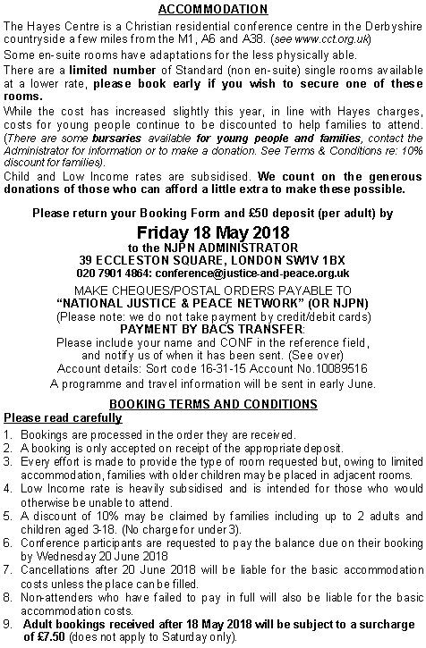

**OTHER INFORMATION** 

**Network members and friends involved with NJPN in the Planning Group:**

NJPN Exec, Apostleship of the Sea, Church Action on Poverty,

Housing Justice, Prison Advice and Care Trust (Pact).

**Please contact the Administrator if you have any queries about any aspect of the conference or this booking.**

**If you have not received confirmation of your booking by 11 June 2018 please contact NJPN. Do not contact The Hayes with queries about bookings.**

**To download more booking forms, or to book by email, go to:**

**www.justice-and-peace.org.uk**

**National Justice & Peace Network:** 39 Eccleston Square, London SW1V 1BX

Tel: 020 7901 4864: Email: **conference@justice-and-peace.org.uk**

*National Justice & Peace Network, 39 Eccleston Square, London SW1V 1BX*

*Registered Charity No 1114947 Company No 5036866*

**BOOKING FORM**

**Please type in details and delete options which do not apply**

ADULTS: (Title, 1st name & Surname) M/F

Address:

Post Code: Tel. No:

Email: Denomination:

Diocese /Organisation (*as you wish to be listed):*

My name and address may be included in Conference address list YES/NO

CHILDREN: Names and ages (*at the time of Conference*)

Special access needs (e.g. Disabled / ground floor)

Special dietary requirements: *Please state to whom this applies*

I require: a ‘signer’ Large print Braille papers

Family room Cot for infant (0-2)

**I am not willing to share a room**

Have you attended an annual J&P Conference before? YES / NO

All prices are **per person** and are all-inclusive £per person No Total due

**EN SUITE:** ADULT Single 192.00

Twin 192.00

Double 192.00

YOUNG ADULT (17-18YRS) 145.00

CHILD (6 – 16YRS) 73.00

(3-5YRS) 15.00

(0-2YRS) Free

LOW INCOME 110.00

PART TIME Fri-Sat 120.00

PART TIME Fri-Sat with Sat evening meal 128.00

PART TIME Sat-Sun 128.00

**STANDARD** (Limited number of single rooms only)

ADULT 164.00

YOUNG ADULT (17-18YRS) 117.00

LOW INCOME 80.00

PART TIME Fri-Sat 107.00

PART TIME Fri-Sat with Sat evening meal 114.00

PART TIME Sat-Sun 114.00

**NON-RESIDENT** ADULT FULL TIME 125.00

SATURDAY ONLY A (No meals provided) 40.00

SATURDAY ONLY B (with lunch) 50.00

SATURDAY ONLY C (with lunch + evening meal) 58.00

**DONATION** (To Gift Aid see declaration below) ------------------ +

**TOTAL** *Plus £7.50 per adult for bookings after 18.05.18 ---------------* +

LESS FAMILY DISCOUNT 10% (See T&C) ------------------ -

LESS DEPOSIT £50 ***per adult*** (non-refundable) ------------------ -

**BALANCE DUE** (Payable by 20 June 2018) ------------------

**Please send my/our Conference Information Pack by: Post Email:**

**GIFT AID DECLARATION**

***Please print off, sign and send in, or bring to the conference***

Please treat as Gift Aid donations all qualifying gifts of money made:

today\_\_\_/ in the past 4 years\_\_\_/ in the future\_\_\_ (Please tick all boxes you wish to apply).

Gift_Aid_30mm_blackI confirm I have paid or will pay an amount of Income Tax and/or Capital Gains Tax for each tax year (6 April to 5 April) that is at least equal to the amount of tax that all the charities or Community Amateur Sports Clubs (CASCs) that I donate to will reclaim on my gifts for that tax year. I understand that other taxes such as VAT and Council Tax do not qualify. I understand the charity will reclaim 28p of tax on every £1 that I gave up to 5 April 2008 and will reclaim 25p of tax on every £1 that I give on or after 6 April 2008.

Signature:.................................................................

Please notify the charity or CASC if you: • Want to cancel this declaration • Change your name or home address • No longer pay sufficient tax on your income and/or capital gains. If you pay Income Tax at the higher or additional rate and want to receive the additional tax due to you, you must include all your Gift Aid donations on your Self Assessment tax return or ask HM Revenue and Customs to adjust your tax code.

*National Justice & Peace Network, 39 Eccleston Square, London SW1V 1BX*

*Registered Charity No 1114947 Company No 5036866*

**CAR SHARING**

I/We are interested in car sharing as: (Delete whichever does not apply)

Driver Passenger Either

 My/Our contact details may be passed to potential sharers YES/NO

**CHECKLIST**

I/We have read and agree to the Booking Terms and Conditions YES/NO

I/We have completed the booking form above YES/NO

I/We have sent a cheque/postal order for £\_\_\_\_\_\_\_\_

OR

I/We have made a BACS transfer of £\_\_\_\_\_\_\_\_

Date \_\_\_\_\_\_\_\_ Reference details \_\_\_\_\_\_\_\_\_\_\_\_\_\_\_\_\_\_\_\_\_\_\_\_

I/We are making an additional donation of £\_\_\_\_\_\_\_\_ which I/we wish

to be Gift Aided, and: have completed the Gift Aid Declaration above;

have previously completed a declaration covering all future donations.

**Database:** The addresses of all attendees at Conference will be added to the mailing database for *Vocation for Justice* and ***Justice & Peace***(NJPN newsletter).

If you do not wish your name to be added, or you already receive these

publications, please put an X next to the sentence below:

Please do not add my details to the database:

**I confirm that NJPN may retain my details on its database to send me updates and notify me of future events and occasional fundraising appeals; and that I agree to receive this information by: email** YES/NO; **post** YES/NO

*Save and return completed form to* [*conference@justice-and-peace.org.uk*](mailto:conference@justice-and-peace.org.uk)