 **National Justice and Peace Network**

**Open Networking Day**

**SATURDAY 17 September 2016**

10.30 – 4.00

St John the Evangelist Church Hall, South Parade, Bath BA2 4AF

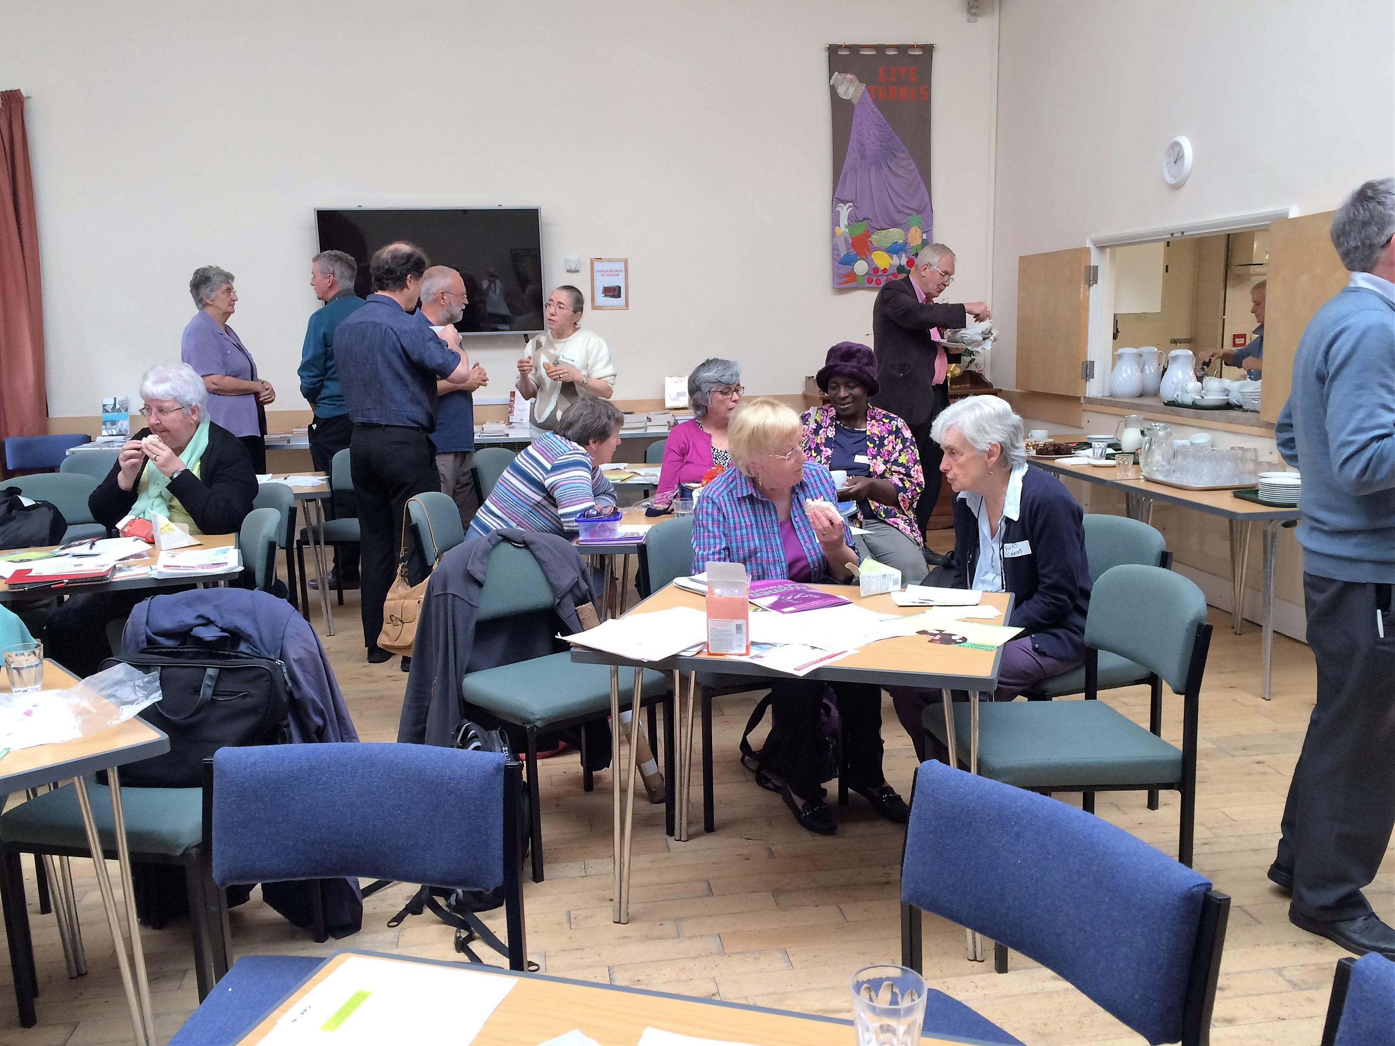

***Refugees:***

***Practical approaches to bringing divided communities together.***

**Speaker: Phil McCarthy**

Director Caritas Social Action Network (CSAN)

**There will be opportunity to hear about justice and peace activities from groups around the country. Representatives of Catholic/Christian Agencies will report on their work and suggest practical ways of becoming involved in campaigning for social justice.**

Tea and coffee will be provided, bring your own lunch.

**For further details contact:**

Ann Kelly Tel: 020 7901 4864

Email: [admin@justice-and-peace.org.uk](mailto:admin@justice-and-peace.org.uk)

