National Justice & Peace Network

39th Annual Conference

Archbishop Romero Trust, CAFOD,
CSAN, Church Action on Poverty,
Columbans, Vincentians in Partnership

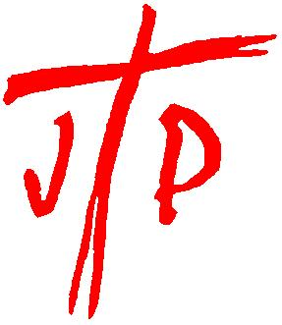

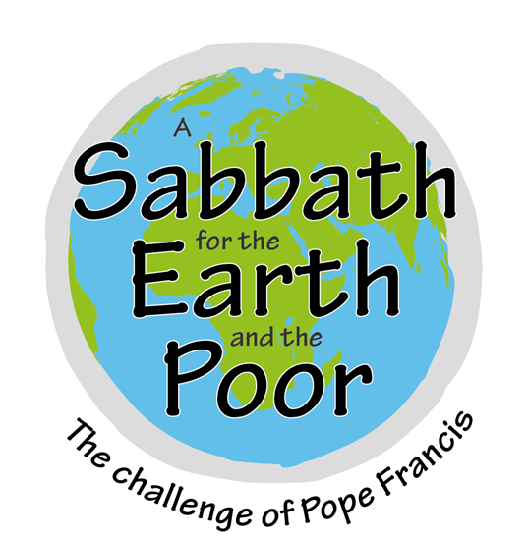

With programmes for children and young people
Friday 21 - Sunday 23 July 2017
The Hayes Conference Centre
Swanwick, Derbyshire

A Sabbath for the Earth and the Poor:
The Challenge of Pope Francis

“Sunday, like the Jewish Sabbath, is meant to be a day which heals our relationships with God, with ourselves, with others and with the world.” (Laudato Si’ para237)

We live in a world where people and nature are more often valued according to their economic capacity or usefulness to humans, rather than their intrinsic value as God’s creation.

In order to be liberated from this commodification, consumerism and utilitarianism, the Sabbath reminds us to rediscover a sense of awe and wonder, to see the beauty in creation and also in relationships, especially with the poor and marginalised.

The conference will seek to: help us understand current realities; find ways to live out and advocate a different value system; and provide a space for creativity, celebration and contemplation.

SPEAKERS

Dr Ruth Valerio is Global Advocacy and Influencing Director for Tearfund, working to mobilise churches around the world to become agents for change and equip them for integral mission. She is the author of Just Living: Faith and community in an age of consumerism, and L is for Lifestyle: Christian living that doesn’t cost the earth. She lives in Chichester with her family.
Fr Peter Hughes, an Irish Columban priest, has spent most of his life as a missionary in Peru, working in some of the most impoverished communities in Lima. He is an advisor to the Instituto Bartolome de las Casas, working in programmes of leadership and social justice. A former executive secretary of the Department of Justice and Solidarity of the Council of Latin American Bishops, he continues to be a theological advisor.
Kathy Galloway is an ordained minister of the Church of Scotland and was leader of the Iona Community from 2002-2009. She is currently head of Christian Aid Scotland. She is also a published poet, author and hymn writer.

Plus Poverty Hearings —hearing from those with direct experience of poverty.

CONFERENCE CHAIR: Susy Brouard, Theology Programme Advisor for CAFOD since 2002.

CELEBRANT: Fr Sean McDonagh, world-renowned eco-theologian.

JUST FAIR

Agencies will be displaying goods and resources, and information and ideas about practical action can be obtained at the “Just Fair” marketplace.

CHILDREN AND YOUNG PEOPLE

Children and young people are a vital part of the NJPN conference. There will be a crèche for children under 5 and a Y-KIDS Programme for 5 to 11 year olds. 12 to 16/18 year olds will explore the conference theme in an active and thought provoking weekend led by InReality Youth Team from Hallam Diocese.

NJPN is committed to the protection of children, young people and vulnerable people.
People of all ages and backgrounds are welcome & encouraged to attend conference.
ACCOMMODATION

The Hayes Centre is a Christian residential conference centre in the Derbyshire countryside a few miles from the M1, A6 and A38. (see www.cct.org.uk)

Some en-suite rooms have adaptations for the less physically able.

There are a limited number of Standard (non en-suite) single rooms available at a lower rate, please book early if you wish to secure one of these rooms.

While the cost has increased slightly this year, in line with Hayes charges, costs for young people continue to be discounted to help families to attend. (There are some bursaries available for young people and families, contact the Administrator for information or to make a donation).

Child and Low Income rates are subsidised. We count on the generous donations of those who can afford a little extra to make these possible.

Please return your Booking Form and £50 deposit (per adult) by

Friday 19 May 2017

to
conference@justice-and-peace.org.uk

PAYMENT BY BACS TRANSFER:
Please include your name and CONF in the reference field,
and notify us of when it has been sent. (See below)
Account details: Sort code 16-31-15 Account No.10089516

(Please note: we do not take payment by credit/debit cards)

A programme and travel information will be sent in early June.
Please indicate if you would like this sent: By post: By email:
(Delete whichever does not apply)

BOOKING TERMS AND CONDITIONS -
Please read carefully

1. Bookings are processed in the order they are received.
2. A booking is only accepted on receipt of the appropriate deposit.
3. Every effort is made to provide the type of room requested but, owing to limited accommodation, families with older children may be placed in adjacent rooms.
4. Low Income rate is heavily subsidised and is intended for those who would otherwise be unable to attend.
5. Conference participants are requested to pay the balance due on their booking by Wednesday 21 June 2017
6. Cancellations after 21 June 2017 will be liable for the basic accommodation costs unless the place can be filled.
7. Non-attenders who have failed to pay in full will also be liable for the basic accommodation costs.
8. Adult bookings received after 19 May 2017 will be subject to a surcharge
of £7.50 (does not apply to Saturday only).

OTHER INFORMATION

WORKSHOPS Planned workshops include: Care for Creation; Sustainable Agriculture; Mining; Indigenous People; Stigmatisation of the poor; Divestment from fossil fuels; Archbishop Romero; Modern Slavery; Volunteering; Workplace Chaplaincy; Refugees; Radical Jesus...

‘FESTIVAL’ In line with the theme of the conference, there will be a space in the programme on Saturday afternoon for creative, relaxing and contemplative activities e.g. walks, art, poetry, gardening… If you have a skill or interest you might be able to share please contact the Administrator by the end of May.

COACH
A coach service is provided from/to Derby Station on Friday evening (5.15pm)and Sunday afternoon (2.00pm) for £7 each way.

MEALS AT CONFERENCE
We have agreed with The Hayes that meals will be provided as far as possible within our budget according to LOAF principles (Locally sourced, Organically produced, Animal friendly, Fairly traded). A meat option will therefore only be given at the Saturday evening meal. This will probably be lamb as this is the most likely to be locally reared and free range. All other meals will be vegetarian (including dairy and eggs).
As usual, The Hayes will do their best to accommodate any other dietary needs; please state these on your booking form.

PACKED LUNCH A packed lunch may be booked for those who have to leave before lunch on Sunday.

Further information and booking forms for these items will be sent with the
pre-conference information pack.

Network members and friends involved with NJPN in the Planning Group:
NJPN Exec, Archbishop Romero Trust, CAFOD, CSAN, Church Action on Poverty, Columbans, Vincentians in Partnership.

Please contact the Administrator if you have any queries about any aspect of the conference or this booking.

If you have not received confirmation of your booking by 12 June 2017 please contact NJPN. Do not contact The Hayes with queries about bookings.

To download booking forms in pdf to book by post go to:
www.justice-and-peace.org.uk

National Justice & Peace Network: 39 Eccleston Square, London SW1V 1BX
Tel: 020 7901 4864: Email: conference@justice-and-peace.org.uk

National Justice & Peace Network, 39 Eccleston Square, London SW1V 1BX
Registered Charity No 1114947 Company No 5036866

BOOKING FORM
Please type in details and delete options which do not apply
ADULTS: (Title, 1st name & Surname) M/F
Address:
Post Code: Tel. No:
Email: Denomination:
Diocese /Organisation (as you wish to be listed):

My name and address may be included in Conference address list YES/NO

CHILDREN: Names and ages (at the time of Conference)

Special access needs (e.g. Disabled / ground floor)

Special dietary requirements: Please state to whom this applies

I require: a ‘signer’ Large print Braille papers
Family room Cot for infant (0-2)

I am not willing to share a room

Have you attended an annual J&P Conference before? YES / NO

All prices are per person and are all-inclusive £per person No Total due
EN SUITE: ADULT Single 184.00
Twin 184.00
Double 184.00
YOUNG ADULT (17-18YRS) 139.00
CHILD (6 – 16YRS) 70.00
(3-5YRS) 15.00
(0-2YRS) Free
LOW INCOME 110.00
PART TIME Fri-Sat 115.00
PART TIME Fri-Sat with Sat evening meal 122.00
PART TIME Sat-Sun 122.00
STANDARD (Limited number of single rooms only)
ADULT 155.00
YOUNG ADULT (17-18YRS) 111.00
LOW INCOME 80.00
PART TIME Fri-Sat 100.00
PART TIME Fri-Sat with Sat evening meal 108.00
PART TIME Sat-Sun 108.00
NON-RESIDENT ADULT FULL TIME 127.00
SATURDAY ONLY A (No meals provided) 40.00
SATURDAY ONLY B (with lunch) 45.00
SATURDAY ONLY C (with lunch + evening meal) 54.00
DONATION (To Gift Aid see declaration below) ------------------ +
TOTAL Plus £7.50 per adult for bookings after 19.05.17 ------
LESS DEPOSIT £45 per adult (non-refundable) ------ -
BALANCE DUE (Payable by 21 June 2017) ------------------

GIFT AID DECLARATION
Please print off, sign and send in, or bring to the conference

Please treat as Gift Aid donations all qualifying gifts of money made:
today___/ in the past 4 years___/ in the future___ (Please tick all boxes you wish to apply).

I confirm I have paid or will pay an amount of Income Tax and/or Capital Gains Tax for each tax year (6 April to 5 April) that is at least equal to the amount of tax that all the charities or Community Amateur Sports Clubs (CASCs) that I donate to will reclaim on my gifts for that tax year. I understand that other taxes such as VAT and Council Tax do not qualify. I understand the charity will reclaim 28p of tax on every £1 that I gave up to 5 April 2008 and will reclaim 25p of tax on every £1 that I give on or after 6 April 2008.

Signature:.................................................................

Please notify the charity or CASC if you: • Want to cancel this declaration • Change your name or home address • No longer pay sufficient tax on your income and/or capital gains. If you pay Income Tax at the higher or additional rate and want to receive the additional tax due to you, you must include all your Gift Aid donations on your Self Assessment tax return or ask HM Revenue and Customs to adjust your tax code.

National Justice & Peace Network, 39 Eccleston Square, London SW1V 1BX
Registered Charity No 1114947 Company No 5036866

CAR SHARING

I/We are interested in car sharing as: (Delete whichever does not apply)

Driver Passenger Either

My/Our contact details may be passed to potential sharers YES/NO

CHECKLIST

I/We have read and agree to the Booking Terms and Conditions

I/We have completed the booking form above

I/We have sent a cheque/postal order for £________

OR

I/We have made a BACS transfer of £________
Date ________ Reference details ________________________

I/We are making an additional donation of £________ which I/we wish
to be Gift Aided, and have completed the Gift Aid Declaration above.

Database: The addresses of all attendees at Conference will be added to the mailing database for Vocation for Justice and Justice & Peace (NJPN newsletter).
If you do not wish your name to be added, or you already receive these
publications, please put an X next to the sentence below:

Please do not add my details to the database:

Save and return completed form to conference@justice-and-peace.org.uk

